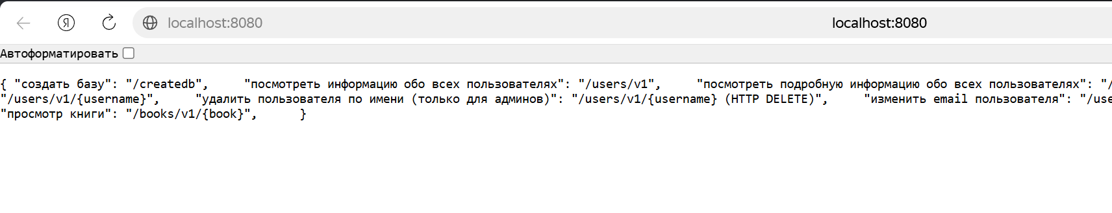
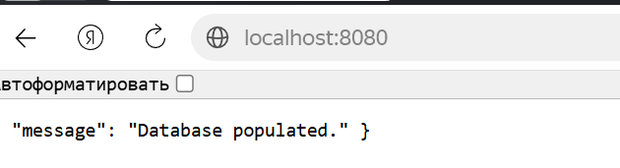
http://localhost:8080/createdb
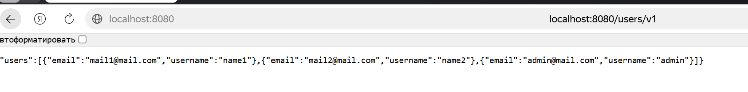
http://localhost:8080/users/v1
http://localhost:8080/users/v1/_debug
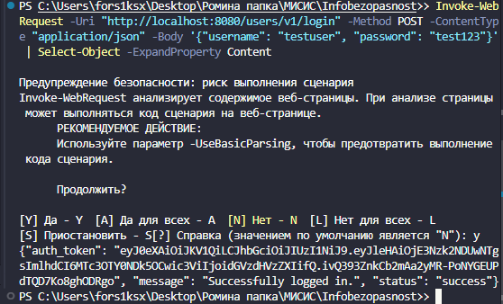
Invoke-WebRequest -Uri "http://localhost:8080/users/v1/login" -Method POST -ContentType "application/json" -Body '{"username": "testuser", "password": "test123"}' | Select-Object -ExpandProperty Content

